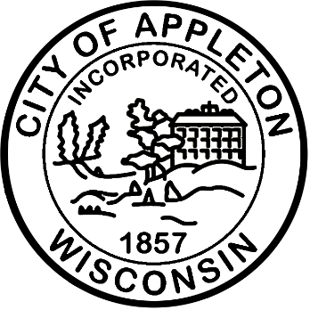
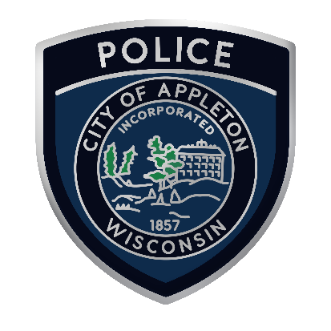

City of Appleton
Police Community Engagement Specialist

Come join the City of Appleton and make an impact today! Each day you’ll have the opportunity to improve the community and make a difference in someone’s day. At the City, you’ll have a chance to grow through ongoing training, work alongside awesome coworkers and leaders, share your thoughts and ideas, and be respected for who you are. Best of all, you’ll have work-life balance to share more time with those you love. Come join the City and make an impact! Apply today.

The City of Appleton is seeking a full-time Community Engagement Specialist. The Police Community Engagement Specialist strengthens relationships between the Appleton Police Department (APD) and the community through strategic communication, and outreach programming. This role enhances APD’s service delivery by promoting transparency, building trust, and ensuring the public is engaged with department initiatives, operations, and events. Working under the general supervision of the Community Resource Unit Captain, this role functions as a bridge between the department, civic groups, neighborhoods, partner organizations, and the broader Appleton community.

Qualifications
This position requires a bachelor’s degree in communications, public administration, or a related field or a combination of experience and training which provides the necessary knowledge, abilities and skills.

Salary
The hiring salary for this position is $26.48 - $32.83 hourly, plus an excellent fringe benefit package including paid time off, health, life, dental, and Wisconsin Retirement System (WRS). The WRS is among the best funded and best managed public pension systems in the country. Employees, spouses, and dependents over the age of 12 months who are covered on the City’s medical plan are eligible to use the Connecting Care Clinic (CCC). The CCC provides primary and acute care services and physical therapy at no cost to the patient.

Apply Now!
If you are interested in applying for this position, please complete an online at appletonwi.gov/careers by Wednesday, October 28, 2026. Resumes without an application will not be considered.

City of Appleton Human Resources
100 N. Appleton Street, 6th floor
Appleton, WI 54911
Phone: (920) 832-6458
Email: humanresources@appletonwi.gov
Equal Opportunity Employer

